23/03/21
THM 415: Finance
Midterm Exam

- What does “Historical Cost” principle tell? What are the 2 exceptions to this very principle (2 Points)
- Rachid Hotel had recorded the following income statement accounts sorted in alphabetical order:
Cost of Goods Sold | $4,030,258
Interest Expenses | $847,693
Operating Expenses | $1,903,542
Sales | $7,963,251
In addition, since Rachid Hotel owns 49 % shares of Guezzal Company, it is entitled to $ 2,033,500 of dividends income from that very company. Moreover, Rachid hotel’s board of directors decided to distribute $ 225,750 as dividends to their shareholders.
The following table reveals Income Tax Rates for Corporate Income for 2020 fiscal year:

Taxable Income | Marginal Tax Rate
$ 0 – $ 100,000 | 7%
$ 100,001 - $225,000 | 9%
$ 225,001 - $ 400,000 | 11%
$ 400,001 - $ 650,000 | 13%
$ 650,001 - $ 900,000 | 15%
$ 900,001 - $ 1,100,000 | 17%
Over $ 1,100,000 | 19%

Lastly, the following table shows dividend income exclusion to avoid double taxation at corporate level.
Ownership Interest | Dividend Exclusion
Less than 15 % | 20%
15 % to 30 % | 40%
30 % to 45 % | 60%
45 % to 62 % | 72%
62 % to 80 % | 83%
More than 80 % | 100%

a) Construct Rachid Hotel Income Statement for the year ended December 31st, 2020. (2 Points)

Moreover, the following is Rachid Hotel’s comparative balance sheet as of December 31st, 2019 and December 31st, 2020:
- Construct Rachid Hotel Statement of Cash Flow for the year ended December 31st, 2020. (3 Points)
- Calculate the Quality of Earnings. Interpret your result. (1 Point)
- Calculate the Capital Acquisition Ratio. Interpret your result. (1 Point)
- Based on the income statement prepared in part a), comparative balance sheet and cash flow statement prepared in part b), analyze the financial situation of Rachid Hotel for the fiscal year 2020. (3 Points)
- Suppose you would like to triple your investment. For this purpose, you deposited in a bank $ 15,941.55 to be compounded weekly at an interest rate of 6.03 %. Calculate the period (in years) needed to reach your objective? (1 Point)
- After examining the various interest rates opportunities, you find that you can borrow from a finance company at 14.53 % compounded semi-annually, from bank A at 14.03 % compounded daily.
a) Which alternative is the most attractive? Why? (1 Point)
b) If you wanted to consider Bank B which offers continuous compounding. What is the maximum interest rate suggested by this very bank to start thinking about the offer? (1 Point)
- Rosier wanted to buy a home that costs $ 300,000. He took a 5-year mortgage loan with semi-annual payments at an annual rate of 4.53 %.
a) How much will Rosier pay each period? (1 Point)
b) Fill in the amortization schedule. (3 Points)
Period | Amount Owed on the Principal (Beg. Period) ($) | Annuity Payment ($) | Interest Portion of the Annuity ($) | Repayment of the Principal Portion of the Annuity ($) | Outstanding Loan Balance ($)
1
2
3
4
5
6
7
8
9
10
c) Suppose that exactly after 2 years, mortgage interest rates fell to 3.53 %. If Rosier has the chance to refinance his loan at that very interest, how much would he pay (on a semi-annual basis) for the remaining 3 years of the loan? (1 Point)
d) If such a refinance opportunity is associated with paying a prepayment penalty fee to the bank of $ 3,000, shall Rosier refinance his loan? Why? Why not? (2 Points)
- Upon evaluation of the distribution of returns of Tosun company, the following possible rate of returns for the upcoming period as long as their probability of occurrence are estimated:
Probability of Occurrence | Rate of Return on Investment
10% | -8.53%
12% | -7.04%
15% | -2.23%
19% | 1.54%
22% | 5.87%
14% | 9.62%
8% | 12.04%
a) Calculate the Expected Rate of Return of Tosun Company stock. (1 Point)
b) What is the risk of the investment in Tosun Company stock as measured using the standard deviation of possible future rates of return? (2 Points)
- Ersin bought some stocks of Destanoğlu Company worth of 1,250,000 Euros 8 years ago. Following is the beginning value of Destanoğlu bought stocks 8 years ago as well as the values at the end of each year up until today (the end of year 8):
Year | Annual Rate of Return | Stock Value (Euros)
0 |  | 1,525,000.00
1 | -5.63% | 1,439,142.50
2 | -2.74% | 1,399,710.00
3 | 4.14% | 1,457,657.99
4 | 6.23% | 1,548,470.08
5 | 2.02% | 1,579,749.18
6 | 7.37% | 1,696,176.69
7 | 8.69% | 1,843,574.45
8 | -2.25% | 1,802,094.02
a) What will be the annual rate of return that Ersin expects to earn next year, if he plans to continue holding Destanoğlu Company stocks? (1 Point)
b) What annual rate of return that Ersin expects over a five-year horizon from holding Destanoğlu Company stocks? (1 Point)
- You own a portfolio consisting of the following stocks:
Stock | Portfolio Allocation | Beta | Expected Return
1 | 12.00% | 0.84 | 15.00%
2 | 23.00% | 1.42 | 21.50%
3 | 18.00% | 1.35 | 17.03%
4 | 25.00% | 0.65 | 14.25%
5 | 22.00% | 1.26 | 15.75%
Assume the risk-free rate is 5.01 % and the expected return on the market portfolio is 14.28 %.
- Calculate the expected return of your portfolio. (0.50 Points)
- Calculate the portfolio beta. (0.50 Points)
- Plot the security market line on a graph. (2 Points)
- From your plot in part c, which stocks appear to be your winners, and which ones appear to be losers? Explain the reason behind your conclusion. (2 Points)
- Why should you consider your conclusion in part d) to be less than certain? (1 Point)
GOOD LUCK!

THM 415 Finance
Formulae Sheet Paper
Midterm Exam
Chapter 3
Profits = Revenues – Expenses
Earnings Per Share (EPS) = Net Income / Number of Outstanding Common Shares
Dividends Per Share (DPS) = Total Dividends Paid / Number of Outstanding Common Shares
Gross Profit Margin = Gross Profits / Net Sales
Operating Profit Margin = Net Operating Income / Net Sales
Net Profit Margin = Net Profits / Net Sales
Total Assets = Total Liabilities + Total Shareholders’ Equity
Net Working Capital = Current Assets – Current Liabilities
Change in Cash Flow (Year_{t}) = Ending cash Balance (Year_{t}) – Ending Cash Bance (Year_{t-1})
Quality of Earnings = Cash Flow From Operations / Net Income
Capital Acquisitions Ratio = Cash Flow From Operations / Cash Paid For Capital Expenditures

Chapter 5
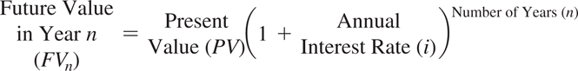
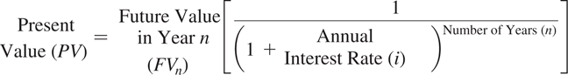
Approximation Formula: Nper = 72/interest rate
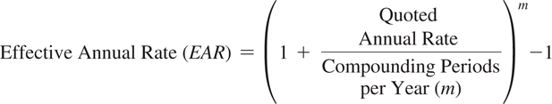
EAR = (e ^{quoted rate} ) – 1 (Continuous Compounding)

Chapter 6
Ordinary Annuity
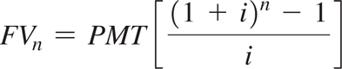
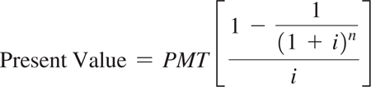
Annuity Due
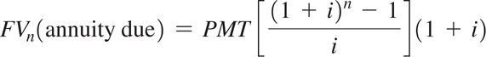
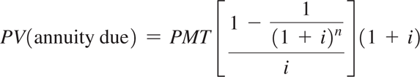
Perpetuity
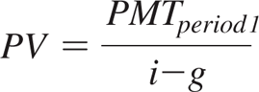

Chapter 7
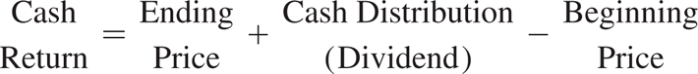
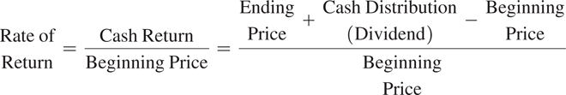
Variance
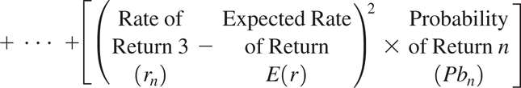

Chapter 8
Portfolio Standard Deviation (with 2 assets)

